**Equity Dynamic Preferred Positioning (DPP)**

**Evgenia Gvozdeva**

|  |  |  |  |
| --- | --- | --- | --- |
| Model Name: Equity Dynamic Preferred Positioning | | Owner 1: Evgenia Gvozdeva | |
| Model Type: Equity Strategy | | Owner 2: Eric Thaut | |
| Vendor Model: N | DI Dependency: Y | Uses other models: Y | Used in othr model: Y |
| Description: Academic and industry research shows that the distribution of asset returns is time-varying. This is true not only for the aggregate market, but also for portfolios sorted on various characteristics. Equity Dynamic Preferred Positioning (DPP) model signals are intended to be used to design a tactical allocation to equity factors (sectors/countries/regions in the next iteration) by systematically over/underweighting factor portfolios based on their expected out/under-performance given different conditions: cycle outlook, valuations and sentiment. The model is currently run monthly. | | | |
| Output: The output consists of cycle, valuation, sentiment and aggregate scores, as well as proposed long-short and dynamic (strategic + long-short) portfolios (<http://tac-app078/DPP/>). | | | |
| Intended use: The output is to lead to actionable recommendations that equity and multi-asset PMs can implement using their dynamic allocation budget. | | | |
| Developed: 2016 | Revised: N/A | Reviewed: 2016 | Validity: 5 years |

Contents

[Model design and methodology 3](#_Toc484676151)

[Modeling approach and methodology 3](#_Toc484676152)

[Supporting research (external or internal) 4](#_Toc484676153)

[Variable description and selection methodology 5](#_Toc484676154)

[Mathematical specification of the model 6](#_Toc484676155)

[Key modeling assumptions 15](#_Toc484676156)

[Comparison with alternative theories and approaches 16](#_Toc484676157)

[Development Testing / Validation 16](#_Toc484676158)

[Data sources 18](#_Toc484676159)

[Dependence on other model output or connection to other models 21](#_Toc484676160)

[Data assumptions 21](#_Toc484676161)

[Implementation 22](#_Toc484676162)

[Details on IT systems used for processing and reporting 22](#_Toc484676163)

[Key implementation assumptions 25](#_Toc484676164)

[Model overrides 25](#_Toc484676165)

[Differences between estimation and implementation 25](#_Toc484676166)

[Production workflow description 25](#_Toc484676167)

[Description of controls and governance process 25](#_Toc484676168)

[Business continuity 26](#_Toc484676169)

[Location of model execution manual 26](#_Toc484676170)

[Location of business continuity plan 26](#_Toc484676171)

[Names and contact info for key personnel 26](#_Toc484676172)

[Evaluation of known unknowns 27](#_Toc484676173)

[Assessment of model’s robustness and accuracy 27](#_Toc484676174)

[Description of key limitations 27](#_Toc484676175)

[Validity ranges for inputs and description of data on which the model was developed 27](#_Toc484676176)

# Model design and methodology

## Modeling approach and methodology

Academic and industry research shows that the distribution of asset returns is time-varying. This is true not only for the aggregate market, but also for portfolios sorted on various characteristics. Dynamic Preferred Positioning (DPP) model signals are intended to be used to design a tactical allocation to factors (sectors/countries/regions in the next iteration) by systematically over/underweighting factor portfolios based on their expected out/under-performance given different conditions: cycle outlook, valuations and sentiment. The output is a scorecard which consists of cycle, valuation, sentiment and aggregate scores, as well as proposed long-short and dynamic (strategic +long-short) portfolios for 12 regions/countries (<http://tac-app078/DPP/>). Scorecard is supposed to add value by disciplining the investment decision makers to resist pitfalls of overconfidence, anchoring and narrow framing and to assess assets based on agreed upon common criteria. Such discipline should increase the chances of achieving consistent and scalable results across investment decisions and over time.

**Exhibit 1:**

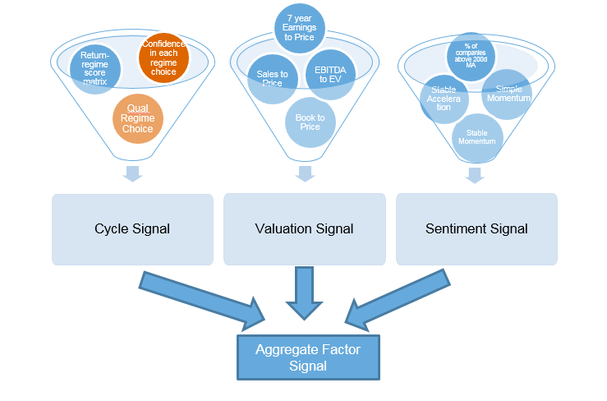

The cycle score for each factor is calculated as equal-weighted combination of earnings, economy and policy scores which are equal-weighted combinations of underlying variables’ scores. Those underlying variables’ scores are based on the strength of historical relationships between excess factor portfolio performance and macro variables’ regimes multiplied by the startegists’ conviction for a particular regime. The valuation score is calculated as an equal weighted combination of four valuation scores: based on Book to Price (B/P), Sales to Price (S/P), 7 year cyclically adjusted Earnings to Price (7YE/P) and EBITDA to EV (EBITDA/EV). For example, to calculate a valuation score based on B/P, we first calculate the premium discount of the factor portfolio to benchmark as $\frac{{P/B}_{factor}}{{P/B}_{benchmark}}-1$ for the available history. We then calculate a standard z-score on those historical observations and multiply it by -1. This is in effect a double relative, what is the valuation today in relation to the benchmark and relative to history. The valuation score is calculated similarly for other fundamental variables. The sentiment score is calculated as an equal weighted combination of four sentiment scores: stable momentum, stable acceleration, simple momentum and percentage of companies above 200 days moving average.

At the beginning of the model development the hypotheses were made about the sensitivities of excess factor performance to changes in macro variables, about the relationships between current valuation levels and observed sentiment and future excess factor performance. The hypotheses were based on academic and industry research as well as the experiences of Russell Investments portfolio managers. The robustness of these economic and other intuitions was verified empirically.

## Supporting research (external or internal)

Similar types of Cycle, Valuation and Sentiment models are run by other asset managers (e.g., Goldman Sachs, Deutsche Bank, etc.) but Russell Investments signal specifications are unique. DPP model is an upgrade to Cycle Valuation Sentiment (CVS) model. Below are the links to old CVS internal papers and DPP internal papers/presentations and to related external papers as well.

**Internal:**

[http://panagon/idmws/DocContent.dll?library=corp^tac-nt-dm1&ID=004819692](http://panagon/idmws/DocContent.dll?library=corp%5etac-nt-dm1&ID=004819692)

[http://panagon/idmws/DocContent.dll?library=corp^tac-nt-dm1&ID=004819694](http://panagon/idmws/DocContent.dll?library=corp%5etac-nt-dm1&ID=004819694)

[\\Frctc\_fs-a\imr\_net\FactorRotationLiterature\DPP Key Documentsv4.docx](\\\\Frctc_fs-a\\imr_net\\FactorRotationLiterature\\DPP Key Documentsv4.docx" \o "\Frctc_fs-aimr_netFactorRotationLiteratureDPP Key Documentsv4.docx)

**External:**

Bibiliography: [\\Frctc\_fs-a\imr\_net\FactorRotationLiterature](file:///\\Frctc_fs-a\imr_net\FactorRotationLiterature)

One of the first papers on factor timing was written by Arnott et al. (1989). They showed that the equity risk premium, market volatility, Treasury Bill yield change, price inflation, economic health (percentage change in the Leading Indicators), and financial liquidity (money supply) have statistical significance as predictors of several factor returns. Another prominent paper was written by Jacobs and Levy (1996) where they studied the effects of changes in various macro variables (corporate bond yield, treasury bond yield, inflation and industrial production) on returns to small cap stocks. Asness et al. (2000) proposed using the spread in valuation multiples (Book to Price, Sales to Price and Earnings to Price) as well as sentiment (analysts’ forecasts of long-term earnings) to forecast value factor performance. Chen and De Bondt (2004) showed that price momentum works for some factor portfolios over the horizon of one year. In most papers, the factors being used are value, growth and size, but Liu et al. (2005) studied the connection between momentum factor profits and growth rate of industrial production. The papers demonstrate the possibility of factor rotation in several regions/countries. For example, Desrosiers et al. (2006) provided promising evidence for style rotation in emerging markets using just two variables: Book to Price and price momentum. Most of the papers on the topic of factor premia forecasting are empirical but Ma and Yan (2015) built a stochastic model that predicts that the value premium declines and the profitability premium is prominent when credit spreads increase under tightening credit conditions, while the opposite happens when credit spreads decrease.

## Variable description and selection methodology

Variable selection was extensive for the Cycle part of the model. The development of Cycle component was started by creating a list of hypotheses[[1]](#footnote-1) about the relationships between excess factor portfolio performance and macro variables. All the hypotheses were tested empirically[[2]](#footnote-2). We describe the testing further in **Cycle score calculation** section below . More than 30 variables were considered and only a subset of economic, earnings and policy variables was chosen. For Cycle part, we currenty use 12 month change in Earnings per share (EPS) growth, 12 month change in EPS dispersion (standard deviation of analysts’ 12 month ahead earnings forecasts), 12 month change in EPS revisions (percentage of analysts who have upgraded their 12 month ahead earnings forecasts + 1/2 of percentage of analysts who have left their 12 month ahead earnings forecasts unchanged) , 12 month change in High Yield spread (BAML High Yield – 10 Year Government yield), 12 month change in Term spread (10 Year Government Yield – 2 Year Government Yield), OECD Composite Leading indicator (CLI) growth , 6 month change in Purchasing Managers’ Index (PMI) or 6 month change in ISM (Institute for Supply Management Manufacturing index) depending on the region, 12 month change in money supply, 12 month change in nominal central bank policy rate, 12 month change in government spending, and 12 month change in broad nominal effective exchange rate. In most cases those variables are region/country specific. If the history is not available, US variables are used as proxies. Additional variables that are used only in some regions are 12 month change in China industrial production growth and 6 month change in copper price.

Variable selection for Valuation part of the model included additional variables (e.g., 12 month trailing Earnings to Price) but only four variables were chosen: Book to Price, Sales to Price, 7 Year Cyclically Adjusted Earnings to Price and EBITDA to EV. This was based on qualitative judgement and testing described in **Development Testing/Validation** section below.

Variable selection for Sentiment part included several bottom up and top down variables but only four variables were chosen: top down stable momentum, top down stable acceleration, top down simple momentum and bottom up percentage of stocks above 200 days moving average. This was based on qualitative judgement and testing described in **Development Testing/Validation** section below.

## Mathematical specification of the model

**Cycle:**

Markov switching model is used to identify the current regimes for different macro variables. This model was chosen because in general it performs better than simple data partition based on the thresholds[[3]](#footnote-3) and is less subjective. The future regime for each variable is forecasted by strategists. Strategists take into consideration historical regimes and estimated magnitudes of macro variable changes needed to justify a shift to a different regime as well as current probabilities of regimes estimated by the model. They also set conviction levels for each regime choice which ranges from 0% to 100%.

**Regime identification: Model description**

Let’s assume that Y is macro variable time series and that two regimes (X) are being identified. Then



**Regime identification: Estimation**

The problem we are solving is to estimate the model parameters given just the observed data. The model is solved by an iterative Expectation-Maximization (EM) algorithm, known as the Baum-Welch algorithm. The Baum-Welch algorithm gives you both the most likely hidden transition probabilities as well as the most likely set of output probabilities given only the observed variables of the model (and an upper bound on the number of hidden states (regimes)). In the example with two regimes, we need to estimate initial state probability, two means, two standard deviations and a transition matrix. The current probabilities (output probabilities) depend on the estimated parameters and are also provided by the algorithm. The regime is assigned based on output probabilities (the regime with the highest probability is the chosen regime).

A Python library hmmlearn is used to estimate the model (hmm.GaussianHMM in particular) (<http://hmmlearn.readthedocs.io/en/latest/tutorial.html>)

**Regime identification**: **Example**

Let’s use US EPS growth as an example. In this case, the regimes are identified for a “second derivative” of EPS (i.e., 12 month change of EPS growth is used). There are three regimes to identify: Decreasing EPS growth over the next 12 months (Regime 0), No change in EPS growth over the next 12 months (Regime 1) and Increasing EPS growth over the next 12 months (Regime 2). Historical time series and regimes for this macro variable are presented in Exhibit 2.

**Exhibit 2**

Regime 0 can be characterized by mean equal to -21% and standard deviation equal to 9%. Regime 1 can be characterized by mean equal to -3% and standard deviation equal to 5%. Regime 2 can be characterized by mean equal to 18% and standard deviation equal to 14%. In Exhibit 3, 1-standard deviation confidence tunnels for each regime are shown. The transition matrix is ((92%, 8%, 0%), (7%, 85%, 7%), (1%, 6%,94%)). The current (at the end of the time series) probabilities of being in Regime 0, 1 and 2 are 0%, 70% and 30%, respectively.

**Exhibit 3**

**Cycle score calculation**

We quantitatively assessed a factor’s excess return in each economic, earnings, and policy regime relative to its long-run outperformance.

This assessment considered the following metrics:

* The magnitude of out (under) performance in each regime
* A measure of the statistical significance of that out (under) performance – i.e. a t-stat
* The hit-rate for the factor’s out (under) performing in that regime
* The full distribution of the factor’s returns in that regime (robustness and outliers checking)

This resulted in a matrix quantifying expected factor outcomes in different business cycle environments which we call frozen matrix (Exhibit 6 a few paragraphs below).

The first step was to assign a score to each factor/macro variable pair where the relationship was strong (i.e., the t statistic was above 1.96 and other criteria described above were met). That score depended on the direction and the hit rate: hit rate between 50% and 55% - the score is 0.5 or -0.5, hit rate between 55% and 60% - the score is 1 or -1, hit rate between 60% and 65% - the score is 1.5 or -1.5, hit rate above 65% - the score is 2 or -2. All the scores (Valuation, Sentiment and Cycle) needed to be between -2 to +2 so that we could combine them without one dominating the other unintentionally.

For example, for Change in HY spread, we had the following hypotheses:

* Profitability premium is a part of Quality premium. Due to lower financial leverage, profitability premium increases with tightening credit conditions (when credit spread increases) and declines when credit conditions improve.
* Similarly, Low volatility should outperform when credit spread increases (and vice versa)
* Due to higher financial leverage, Value premium declines with tightening credit conditions (when credit spread increases) and increases when credit conditions improve.
* Momentum performs in an opposite way to Value conditional on this variable.

In the US, we used HY spread history starting from 1988 to test the hypotheses. The summary of the results is below:

**Exhibit 4**

|  |  |  |  |  |  |
| --- | --- | --- | --- | --- | --- |
| US |  | Quality | Low Volatility | Value | Momentum |
| Decreasing | Excess return | **-16.12%** | **-4.76%** | **17.39%** | **-20.93%** |
|  | t-stat | -8.38 | -4.54 | 7.14 | -7.47 |
|  | hit rate | 97% | 84% | 74% | 74% |
| Unchanged | Excess return | **-1.67%** | -0.64% | **2.79%** | 0.23% |
|  | t-stat | -2.31 | -1.56 | 3.05 | 0.22 |
| Increasing | Excess return | **8.92%** | **2.86%** | **-11.87%** | **6.15%** |
|  | t-stat | 8.21 | 4.82 | -8.62 | 3.88 |
|  | hit rate | 80% | 73% | 91% | 72% |

All our hypotheses were confirmed in this case (|t-stat| > 1.96). We generally ignored the results in unchanged regime and the original scores calculated using hit rates in this case were:

**Exhibit 5**

|  |  |  |  |  |
| --- | --- | --- | --- | --- |
| US | Quality | Low Volatility | Value | Momentum |
| Decreasing | -2 | -2 | 2 | -2 |
| Unchanged | 0 | 0 | 0 | 0 |
| Increasing | 2 | 2 | -2 | 2 |

The second step was to make the frozen matrices more consistent across the regions/countries. In most cases, the differences in the frozen matrices were not big and the scores were always in the same direction, but we decided to use a single frozen matrix across regions/countries where we took the average of region/country specific frozen matrices but US entered into the calculation 3 times given the robustness and the length of the history. The final scores are rounded to the closest whole (or whole and a half) number.

For example, in the case of HY spread, the final matrix was calculated as follows:

3/10 X

|  |  |  |  |  |
| --- | --- | --- | --- | --- |
| US | Quality | Low Volatility | Value | Momentum |
| Decreasing | -2 | -2 | 2 | -2 |
| Unchanged | 0 | 0 | 0 | 0 |
| Increasing | 2 | 2 | -2 | 2 |

+ 1/10 X

|  |  |  |  |  |
| --- | --- | --- | --- | --- |
| Asia Pac | Quality | Low Volatility | Value | Momentum |
| Decreasing | -2 | -2 | 2 | -2 |
| Unchanged | 0 | 0 | 0 | 0 |
| Increasing | 2 | 2 | -2 | 0 |
| + 1/10 X |  |  |  |  |
| Australia | Quality | Low Volatility | Value | Momentum |
| Decreasing | -2 | -2 | 2 | -2 |
| Unchanged | 0 | 0 | 0 | 0 |
| Increasing | 2 | 2 | -2 | 0 |
| + 1/10 X |  |  |  |  |
| Canada | Quality | Low Volatility | Value | Momentum |
| Decreasing | -2 | -2 | 2 | -2 |
| Unchanged | 0 | 0 | 0 | 0 |
| Increasing | 2 | 2 | -2 | 0 |
| + 1/10 X |  |  |  |  |
| EM | Quality | Low Volatility | Value | Momentum |
| Decreasing | -2 | -2 | 2 | -2 |
| Unchanged | 0 | 0 | 0 | 0 |
| Increasing | 2 | 2 | -2 | 0 |
| + 1/10 X |  |  |  |  |
| Europe | Quality | Low Volatility | Value | Momentum |
| Decreasing | -2 | -2 | 2 | -2 |
| Unchanged | 0 | 0 | 0 | 0 |
| Increasing | 2 | 2 | -2 | 0 |
| + 1/10 X |  |  |  |  |
| Japan | Quality | Low Volatility | Value | Momentum |
| Decreasing | -2 | -2 | 2 | -2 |
| Unchanged | 0 | 0 | 0 | 0 |
| Increasing | 2 | 2 | -2 | 0 |
| + 1/10 X |  |  |  |  |
| UK | Quality | Low Volatility | Value | Momentum |
| Decreasing | -2 | -2 | 2 | -2 |
| Unchanged | 0 | 0 | 0 | 0 |
| Increasing | 2 | 2 | -2 | 0 |

=

|  |  |  |  |  |
| --- | --- | --- | --- | --- |
| **Final** | **Quality** | **Low Volatility** | **Value** | **Momentum** |
| **Decreasing** | **-2** | **-2** | **2** | **-2** |
| **Unchanged** | **0** | **0** | **0** | **0** |
| **Increasing** | **2** | **2** | **-2** | **0.5** |

These frozen matrices are not supposed to be changed frequently but are supposed to be reviewed every several years.

**Exhibit 6:** Example of the full frozen matrix (matrices for other regions can be found at <http://tac-app078/DPP/>)

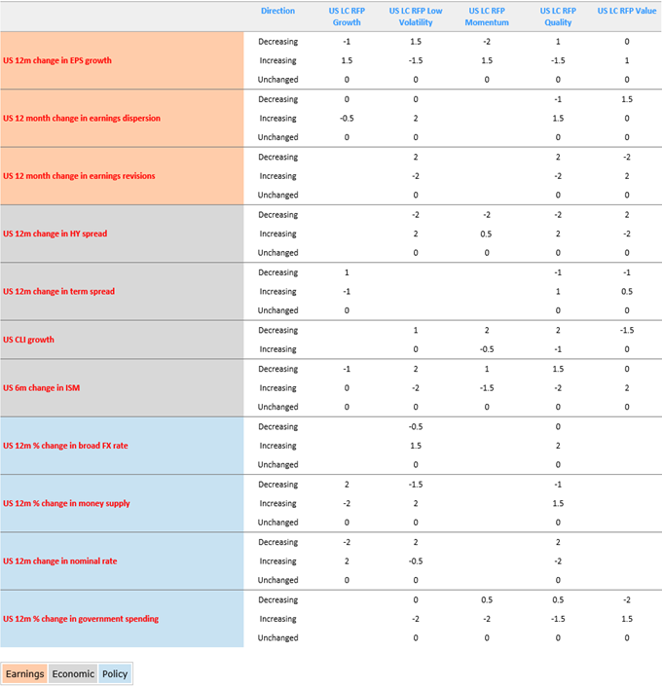

The next steps of the Cycle score calculation process are qualitative and depend on Strategists’ team inputs. Final cycle score for each factor is calculated as equal-weighted combination of earnings, economy and policy scores which are equal-weighted combinations of underlying variables’ scores (frozen score in chosen future regime (final regime) multiplied by conviction). Below is a simplified example of cycle score calculation for one region:

**Exhibit 7:** 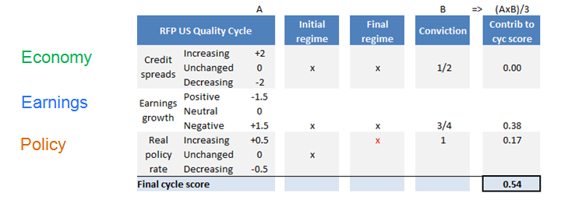

In some cases (e.g., Global, Developed ex US), an aggregate cycle score is calculated. In those cases, each economic variable regime is a GDP weighted combination of the underlying regions’ economic regimes, each earnings variable regime is a market capitalization weighted combination of underlying regions’ earnings regimes, and each policy variable regime is a money supply (M2) weighted combination of underlying regions’ policy regimes. The rest of the calculation is similar to single region calculation.

**Valuation:**

**Raw values**

Book to Price (B/P), Sales to Price (S/P), 7 year cyclically adjusted Earnings to Price (7YE/P) and EBITDA to EV (EBITDA/EV) are first calculated for each stock in the portfolio (including parent benchmark).

After that, within each portfolio, the outliers are adjusted through winsorization. The values above High Outlier Value are replaced with High Outlier Value; the values below Low Outlier Value are replaced with Low Outlier Value. The High Outlier Value is calculated as 1st quartile breakpoint plus 3 times the inter-quartile range; the Low Outlier Value is calculated as 3rd quartile breakpoint minus 3 times the inter-quartile range. This is a standard Russell Investments approach for fundamental data and it is consistent with the approach utilized in Russell Investments equity profiles . No substitution rules are employed at the moment.

The portfolio level B/P, S/P, 7YE/P and EBITDA/EV values are calculated as market cap weighted averages.

**Premium/discount**

The premium/discount of the portfolio to parent benchmark is calculated as $\frac{{P/F}_{subindex}}{{P/F}_{parent}}-1$ where P is price or Enterprise Value and F is the corresponding fundamental (B, S or 7YE, EV).

In the viewer charts, blue line shows historical premium/discount, green dotted line shows mean value and red dotted lines are plus/minus one standard deviation (based on all historical observations).

**Exhibit 8:** Example of B/P premium/discount chart

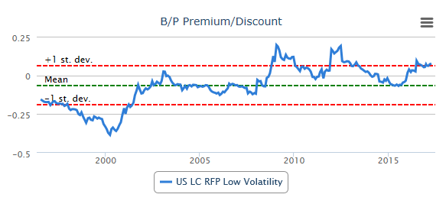

**Valuation score calculation**

The first step is to take all the available history of premiums/discounts for each fundamental and for each portfolio, to calculate an expanding window z-score on the historical observations and to multiply it by -1. This is in effect a double relative, what is the valuation today in relation to the parent index and relative to history.

If the z-score is above 0 (i.e., cheaper than the parent relative to history), the cell is colored green and if the z-score is below 0 (i.e., more expensive than the parent relative to history), the cell is colored red. In the charts, the z-scores are shown for the entire history.

**Exhibit 9:** Example of B/P valuation score chart

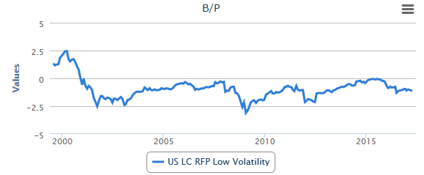

**Composite valuation score**

The composite valuation score is calculated as an equal weighted combination of four valuation scores. To avoid data mining and to keep the calculation simple, equal weights were chosen. If individual scores are not available for some period (e.g., EBITDA/EV score before 2001), the composite score is calculated as an average of the remaining valuation scores. Composite scores above 2 are replaced with 2; composite scores below -2 are replaced with -2. To be consistent with other scores (Cycle and Sentiment) the score needs to be between -2 and +2. The Tech bubble period was the only period in the available history when this replacement was triggered.

**Exhibit 10:** Example of composite valuation score chart

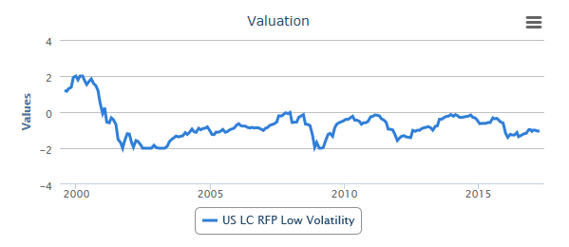

**Sentiment:**

The composite sentiment score is calculated as an equal weighted combination of four sentiment scores: Stable Momentum (top down), Stable Acceleration (top down), Simple Momentum (top down) and Percentage of Companies above 200 Days Moving Average (bottom up). To avoid data mining and to keep the calculation simple, equal weights were chosen. All four sentiment scores have different scales, in order to put them on the same scale the sigmoid function is used which puts the scores between -2 and 2. This also makes the Sentiment score consistent with Cycle and Valuation scores.

**Stable Momentum**

The first step is to run a linear trend regression[[4]](#footnote-4) using cumulative excess returns for each portfolio over the corresponding benchmark (parent). It is estimated weekly for 52 weeks period. The raw score is calculated as trend coefficient value divided by the standard error of the coefficient (essentially a t-statistic of the trend coefficient). Then we calculate an expanding window z-score of the raw values.

**Stable Acceleration**

The first step is to run a quadratic trend regression[[5]](#footnote-5) using cumulative excess returns for each portfolio over the corresponding benchmark (parent). It is estimated weekly for 52 weeks period. The raw score is calculated as quadratic term coefficient value divided by the standard error of the coefficient (essentially a t-statistic of the quadratic term coefficient). Linear term is not being used. Then we calculate an expanding window z-score of the raw values.

**Simple Momentum**

The first step is to calculate excess returns for each factor over the corresponding benchmark (parent) for 52 weeks period. Then we calculate an expanding window z-score of the raw values.

**Percentage of Companies above 200 Days Moving Average**

The first step is for each portfolio and the parent benchmark to calculate market cap weighted indicator (percentage) of stocks above 200 days Moving Average. The next step is to subtract the benchmark percentage from each of the portfolio percentages. Then we calculate an expanding window z-score of the raw values.

**Aggregate Signal:**

The aggregate signal is calculated as 40% Cycle score + 30% Composite Valuation score + 30% Composite Sentiment score. These set of weights was originally chosen by the Startegists’ team to be used in Russell Investments’ CVS models.

**Portfolio Construction:**

The aggregate signal is translated linearly into an unconstrained Long-Short Tactical Portfolio (LSTP). Tactical Weight = Aggregate Signal \* 0.25 (multiplier), rounded to 5% increments, with no forced ranking and parent benchmark is used as a “flex” allocation. The risk multiplier was chosen so that the tracking error could fit the risk budget allocated to dynamic management based on historical simulations. Strategic benchmarks don’t change very often and are approved by ISC. Dynamic Portfolio is equal to Strategic benchmark plus LSTP. Portfolio managers can qualitatively adjust the LSTP weights and the explanations for adjustments are recorded in the DPP tool/viewer.

## Key modeling assumptions

The main assumption of the scorecard approach is that there is a cause-effect relationship between scores and future excess returns of factors/sectors/countries. Another more specific assumption is related to Markov Regime Switching model used to create the Cycle score. We assume that macro variables (changes in most cases) are time dependent and normally distributed.

## Comparison with alternative theories and approaches

Regression based approach is an alternative to a scorecard based approach. To make the model easy to interpret by everyone, a decision to use a simpler approach was made. Also, scorecard is nonparametic and thus would not be influenced as much by outliers or other data issues and it allows for subjective weighting of signals to minimize data mining.

## Development Testing / Validation

Cross-sectional and time-series signal testing framework was used to evaluate the validity of the signals.

Cross-sectional:

At each point in time we sort assets based on a signal and form equal-weighted top and bottom portfolios. In the case of factors only, we have 6 factor portfolios and thus top portfolio consists of 2 factor portfolios and bottom portfolio consists of 2 factor portfolios. We consider several horizons: 3 months, 6 months, 12 months, 24 months and 36 months. For each horizon, we need to produce the following metrics (together with significance test results) for the whole sample (1996-2016) and subsamples (1996 -2006, 2007-2016):

1. Difference in performance over a horizon between top and bottom portfolios. To test the significance we use difference of means test (t-test) with the assumption of normality and variance homogeneity (significance level is set at 5%).
2. Percentage of time the top portfolio outperforms the bottom portfolio over a horizon (time-series hit rate). We use nonparametric Chi-square test to test whether the hit rates (proportions) are different from 50% with a minimum significance of 5%.
3. Each month calculate Pearson (rank) correlation between a signal and forward excess return over a horizon (Information coefficient). Here we calculate excess return over a relevant benchmark. Take the average of ICs across months. We use a t-test to test whether the mean of correlation values is different from 0 (assumption of normality, significance level is set at 5%).

Time-series:

In the time series approach we look to evaluate signals in two ways:

* First, we look at the raw signals then evaluate them using hit rate and model IC. We call it pre-bet analysis. This is done using forward excess returns for various horizons (3, 6, 12, 24, 36 months).  The Model IC is calculated as the Pearson correlation between the signal and the forward return. The hit rate is calculated as the number of times the signal and forward return had the same sign divided by the total number of observations.
* Second, we make bets with the signals given thresholds and then do a suite of analytics common to portfolio analysis (Ex Returns, IR, max drawdown etc.).  We do this monthly from the start of where signals are generated. To do this post-bet analysis we must create thresholds from which to bet. Here we have chosen a set of rules which are written out below. We have picked thresholds for buying (+1), selling (-1), and closing (0.5,-0.5).
* If the indicator >1, long position (+1)
* If the indicator falls below 0.5, exit the long to close position (0)
* If the indicator < -1, short position (-1)
* If the indicator rises above -0.5, exit the short to close position (0)

All the monthly signal outputs are recorded which allows for model evaluation on an ongoing basis.

The results of the tests can be found here:

<http://ent-sharepoint/sites/InvestmentDivision/EDPP/_layouts/xlviewer.aspx?id=/sites/InvestmentDivision/EDPP/Aggregation%20and%20Model%20Portfolios/Combined%20testing%20framework%20-%20Aggregation.xlsx>

<http://ent-sharepoint/sites/InvestmentDivision/EDPP/_layouts/xlviewer.aspx?id=/sites/InvestmentDivision/EDPP/Aggregation%20and%20Model%20Portfolios/Combined%20testing%20framework%20-%20Cycle.xlsx>

<http://ent-sharepoint/sites/InvestmentDivision/EDPP/_layouts/xlviewer.aspx?id=/sites/InvestmentDivision/EDPP/Aggregation%20and%20Model%20Portfolios/Combined%20testing%20framework%20-%20Value.xlsx>

<http://ent-sharepoint/sites/InvestmentDivision/EDPP/_layouts/xlviewer.aspx?id=/sites/InvestmentDivision/EDPP/Aggregation%20and%20Model%20Portfolios/Combined%20testing%20framework%20-%20Sentiment.xlsx>

# Data sources

The DPP model is highly dependent on the data it uses. We expect the model not to be very sensitive to the change in the price, fundamental and macro data sources if the data sources are of high quality. However, if we lose any of the data sources completely, it will impact the output.

**Exhibit 11:** List of data sources

|  |  |  |  |  |  |
| --- | --- | --- | --- | --- | --- |
| Name: data items | Location | Update frequency | History Y/N | Revisions | Sustainability |
| Wordscope (QAI):  Fundamentals (Book, Sales, Earnings, EBITDA, EV) | QTCDB033PC\DBSQL033PC | Daily | Y | Done by Thompson Reuters/Worldscope | Worldscope is sustainable, could be reached through another data aggregator/provider |
| Datastream (QAI):  Pricing (price returns), market values | QTCDB033PC\DBSQL033PC | Daily | Y | Done by Thompson Reuters/Datastream | Datastream is sustainable, could be reached through another data aggregator/provider |
| Indexes (QAI):  Holdings for:  'SPASX 100',  ‘SPASX Small Ords’ | QTCDB033PC\DBSQL033PC | Daily | Y | Done by Thompson Reuters | Idexes are sustainable, could be reached through another data aggregator/provider |
| Magellan:  Holdings and price returns for:  'RGI Mega',  'RGI LC',  ‘JP SC’,  'Asia Pac ex Japan LC',  'Dev Europe ex UK Mega',  'Dev Europe ex UK LC',  'EM AC',  'US SC',  'Dev ex US Mega',  'Dev ex US LC',  'Dev Mega',  'Dev LC' | QTCDB033PC\DBSQL033PC | Daily | Y | Done by FTSE/Russell Investments | Sustainable as long as we continue getting data from FTSE |
| DIRebalance:  Holdings and price returns for:  'Global LC RFP Growth',  'Global LC RFP Low Volatility', 'Global LC RFP Momentum',  'Global LC RFP Quality',  'Global LC RFP Value',  'US LC RFP Growth',  'US LC RFP Low Volatility',  'US LC RFP Momentum',  'US LC RFP Quality',  'US LC RFP Value',  'SPASX 100 Russell Growth',  'SPASX 100 Russell Low Volatility', 'SPASX 100 Russell Momentum',  'SPASX 100 Russell Quality',  'SPASX 100 Russell Value',  'SPASX Small Ords Russell Low Volatility',  ‘SPASX Small Ords Russell Growth',  'SPASX Small Ords Russell Momentum',  'SPASX Small Ords Russell Quality',  'SPASX Small Ords Russell Value',  'Asia Pac ex Japan LC RFP Growth', 'Asia Pac ex Japan LC RFP Low Volatility',  'Asia Pac ex Japan LC RFP Momentum',  'Asia Pac ex Japan LC RFP Quality', 'Asia Pac ex Japan LC RFP Value',  'FTSE UK Growth',  'FTSE UK Low Volatility',  'FTSE UK Momentum',  'FTSE UK Quality',  'FTSE UK Value',  'TOPIX Growth',  'TOPIX Low Volatility',  'TOPIX Momentum',  'TOPIX Quality',  'TOPIX Value',  'Dev Europe ex UK LC RFP Growth', 'Dev Europe ex UK LC RFP Low Volatility',  'Dev Europe ex UK LC RFP Momentum',  'Dev Europe ex UK LC RFP Quality', 'Dev Europe ex UK LC RFP Value',  'EM LC RFP Growth',  'EM LC RFP Low Volatility',  'EM LC RFP Momentum',  'EM LC RFP Quality',  'EM LC RFP Value',  'US SC RFP Growth',  'US SC RFP Low Volatility',  'US SC RFP Momentum',  'US SC RFP Quality',  'US SC RFP Value',  'Dev ex US LC RFP Growth',  'Dev ex US LC RFP Low Volatility', 'Dev ex US LC RFP Momentum', 'Dev ex US LC RFP Quality',  'Dev ex US LC RFP Value',  'Dev LC RFP Growth',  'Dev LC RFP Low Volatility',  'Dev LC RFP Momentum',  'Dev LC RFP Quality',  'Dev LC RFP Value' | QTC-DB253P | Daily | Y | Done by Russell Investments | Sustainable (internal database) |
| PACE:  Holdings for:  'SPTSX',  'FTSE 100',  'FTSE All Share',  ‘TOPIX’ | DBPROD24C\DBSQL24C | Daily | Y | NA | Not very sustainable (planning to migrate to another data source in the future) |
| Datastream (Excel add on):  All macro variables except Japan OAS | Paul Eitelman’s machine | Monthly | Y | Done by Datastream | Sustainable |
| Barclays (website):  Japan OAS for BAA Corporate Quality | <https://live.barcap.com> (requires password) | Monthly | Y | Done by Barclays | Sustainable, just one variable is currently sourced from Barclays |

## Dependence on other model output or connection to other models

The model is dependent on Strategists’ macro variables forecasts which can be based on other models.

## Data assumptions

For Valuation data (e.g., B/P, etc.), within each universe the outliers are adjusted through winsorization. The approach is similar to that of Russell Investments Equity Profiles. The values above High Outlier Value are replaced with High Outlier Value; the values below Low Outlier Value are replaced with Low Outlier Value. The High Outlier Value is calculated as 1st quartile breakpoint plus 3 times the inter-quartile range; the Low Outlier Value is calculated as 3rd quartile breakpoint minus 3 times the inter-quartile range. No substitution rules are employed now.

# Implementation

## Details on IT systems used for processing and reporting

The calculations for the model are done in Python. The DPP module is a part of FASTR (Factor and Strategy Research platform). SQL queries to extract data from underlying data sources are embedded into Python scripts.

The most recent version of FASTR used for DPP can be downloaded from Gitlab or can be found at

[\\Frctc\_fs-f\frs\_net\DPP\_docs\fastr4\](file:///\\Frctc_fs-f\frs_net\DPP_docs\fastr4\)

Code documentation can be found at [\\FRCTC\_FS-F\FRS\_NET\DPP\_docs\build\DPP.html](file:///\\FRCTC_FS-F\FRS_NET\DPP_docs\build\DPP.html)

Processing is done in Jupyter Notebooks ([\\FRCTC\_FS-F\FRS\_NET\DPP\Notebooks\](file:///\\FRCTC_FS-F\FRS_NET\DPP\Notebooks\))

**DPP Cycle Notebook:**

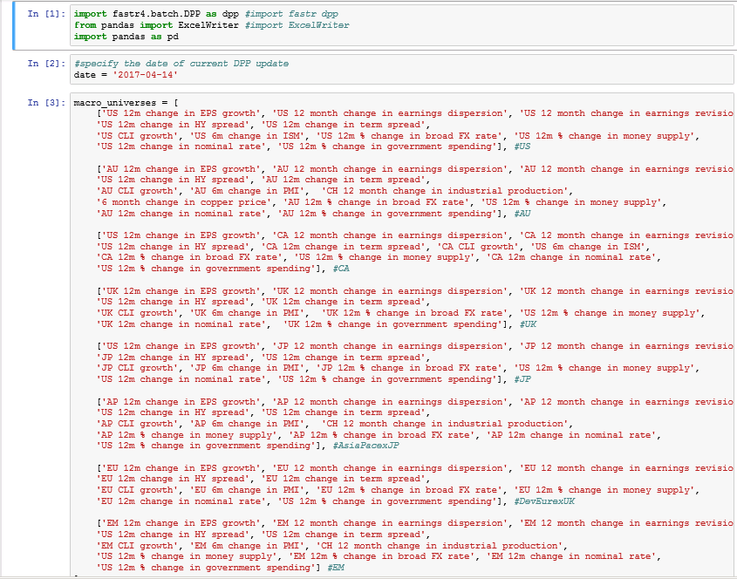

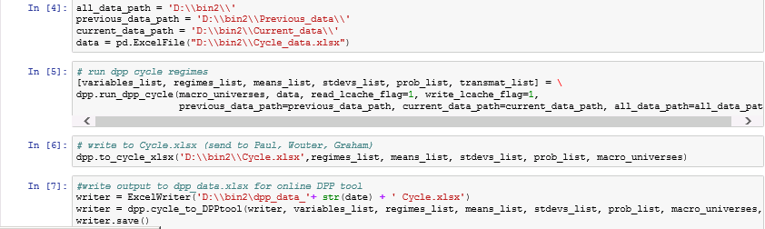

**DPP Main Notebook:**

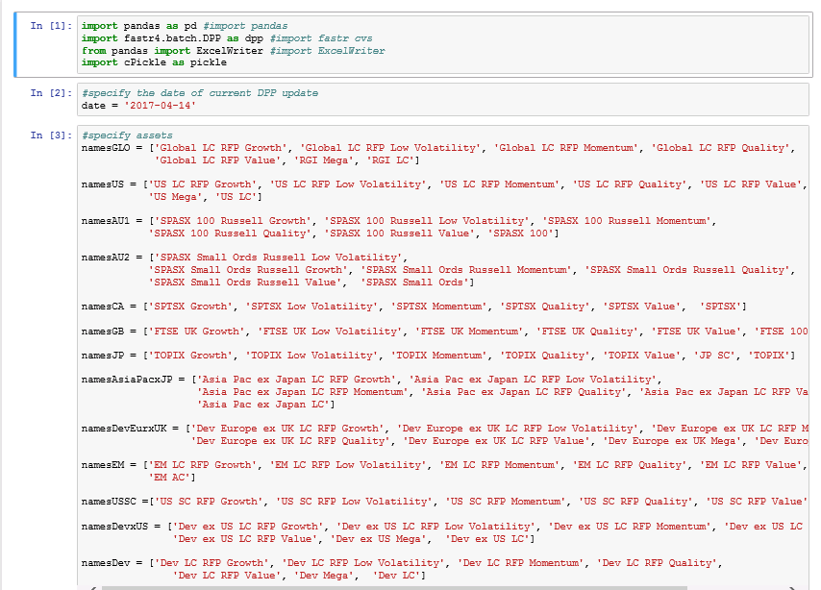

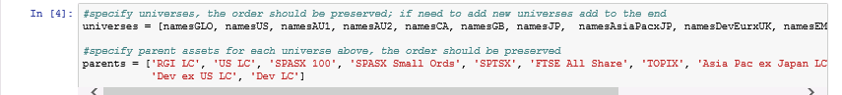

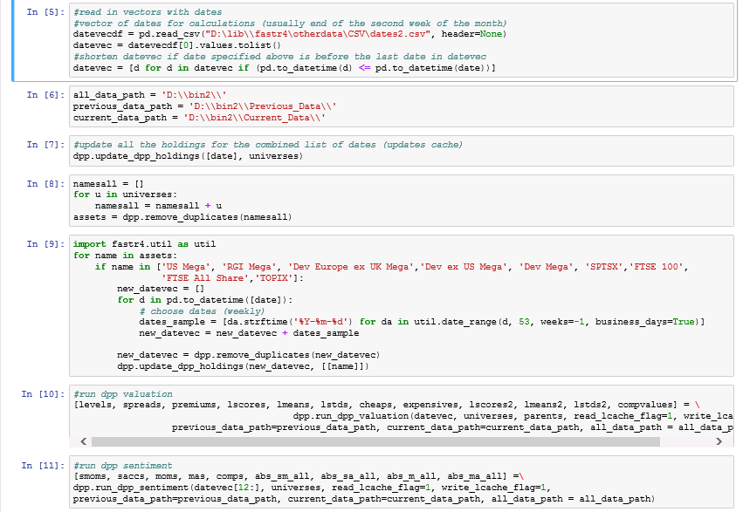

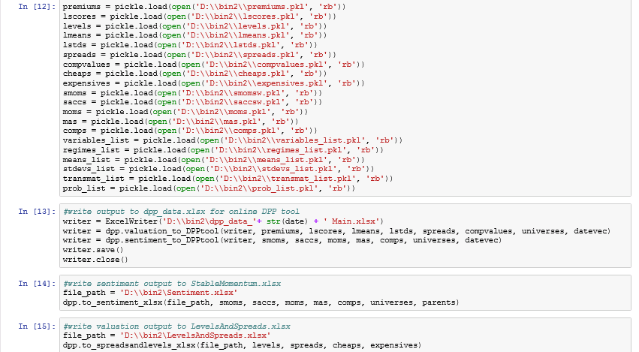

The outputs are then shown in the tool/viewer (<http://tac-app078/DPP/>).

## Key implementation assumptions

### Model overrides

Model overrides are done in regional Portfolio Strategy meetings. All the overrides and explanations are recorded in the tool/viewer (<http://tac-app078/DPP/>).

### Differences between estimation and implementation

The tactical weights estimated by the model are rounded to the increments of 5%.

## Production workflow description

**Exhibit 12**

**Update cache on network drive**

**Send outputs of Main run to be uploaded into viewer**

**Obtain macro data from Strategists’ team**

**Send outputs of Cycle run to Strategists’ team**

**Send outputs of Cycle run to be uploaded into viewer**

## Description of controls and governance process

1. Review macro data from Strategists’ team, replace with NA where macro data is missing for recent dates.
2. Update historical dates in input file with current as of date (fastr4\Other data\CSV\dates2.csv).
3. Make sure to update cache from [\\FRCTC\_FS-F\FRS\_NET\DPP\Previous\_Data\](file:///\\FRCTC_FS-F\FRS_NET\DPP\Previous_Data\).
4. Set date in second cell to as of date in DPP Cycle notebook and run it cell by cell.
5. Send Cycle outputs to Strategists’ team for review, send Cycle output to be loaded into DPP tool. Review the regime charts after the tool is updated.
6. Set date in second cell to as of date in DPP Main notebook and run it cell by cell.
7. Send Valuation and Sentiment outputs to be loaded into DPP tool. Review all the Valuation and Sentiment charts after the tool is updated.
8. Save new cache to dated folder [\\FRCTC\_FS-F\FRS\_NET\DPP\Previous\_Data\](file:///\\FRCTC_FS-F\FRS_NET\DPP\Previous_Data\).
9. Save all other outputs to dated folder [\\FRCTC\_FS-F\FRS\_NET\DPP\Outputs\](file:///\\FRCTC_FS-F\FRS_NET\DPP\Outputs\).

Governance is conducted by Equity DPP Steering committee. The meetings usually occur every quarter.

## Business continuity

### Location of model execution manual

Execution can be done using two Jupyter notebooks located at:

[\\Frctc\_fs-f\frs\_net\DPP\Notebooks\](file:///\\Frctc_fs-f\frs_net\DPP\Notebooks\)

### Location of business continuity plan

NA

### Names and contact info for key personnel

|  |  |  |
| --- | --- | --- |
| Personnel | Work phone | Cell phone |
| Evgenia Gvozdeva | 206-505-4697 | 425-281-4300 |
| Eric Thaut | 206-505-1771 | 253-312-6330 |

# Evaluation of known unknowns

## Assessment of model’s robustness and accuracy

In the backtests we get a hit rate higher than 60% on average. We should not expect such a high hit rate for a live strategy. Also, in the backtest we get ~2% excess return on average at 6 months horizon. We shouldn’t expect such a high excess return for a live strategy.

## Description of key limitations

The model depends on Cycle forecasts from the Strategists’ team. Due to lack of historical forecasts from that team, the backtest of the Cycle part included perfect foresight for the macro variables.

It is not appropriate to use the model for longer time horizons (2+ years).

## Validity ranges for inputs and description of data on which the model was developed

No interpolations/extrapolations are made with the model data. The outliers are treated through transformations.

1. See <http://ent-sharepoint/sites/InvestmentDivision/EDPP/_layouts/xlviewer.aspx?id=/sites/InvestmentDivision/EDPP/Cycle/DPP%20equity%20cycle%20-%20hypotheses%20and%20macro%20data.xlsx> [↑](#footnote-ref-1)
2. See the results in Excel files named “Regimes….” here:

   <http://ent-sharepoint/sites/InvestmentDivision/EDPP/Cycle/Forms/AllItems.aspx>

   There you can also find the length of the history used for each macro variable. [↑](#footnote-ref-2)
3. See “Regime Shifts: Implications for Dynamic Strategies” by Kritzman et al. (2012) [↑](#footnote-ref-3)
4. We assume that the process is trend stationary. This regression is not used for forecasting, it is used to estimate the stability of the trend. We believe that biases which might arise due to heteroscedasticity and autocorrelation will impact all the scores in the same way and thus will not impact the normalized scores. [↑](#footnote-ref-4)
5. We assume that the process is trend stationary. This regression is not used for forecasting, it is used to estimate the stability of the trend. We believe that biases which might arise due to heteroscedasticity and autocorrelation will impact all the scores in the same way and thus will not impact the normalized scores. [↑](#footnote-ref-5)